

**WEB BASED LEARNING ASSESSMENT SYSTEM**

**BY**

**MUDATHIR MUKTHAR MUHAMMAD**

**NAS/STE/20/1054**

**A PROJECT SUBMITTED TO THE DEPARTMENT**

**OF**

**SOFTWARE ENGINEERING AND CYBER SECURITY**

**COLLEGE OF COMPUTING AND INFORMATION SCIENCE,**

**AL-QALAM UNIVERSITY KATSINA**

**IN PARTIAL FULFILMENT OF THE REQUIREMENT FOR THE AWARD**

**OF BACHELOR’S DEGREE**

**IN**

**SOFTWARE ENGINEERING**

**MAY, 2024**

**CHAPTER ONE**

**INTRODUCTION**

**1.0 Introduction**

This chapter provides a comprehensive overview of the Learning Assessment System developed using PHP, Bootstrap, and MySQL. It outlines the background of the project, the problems addressed, the aim and objectives, the significance, the scope, and the operational definitions of key terms used throughout the documentation.

**1.1 Background**

In recent years, the advancement of technology has significantly impacted the educational sector, leading to a notable shift towards digital learning and assessment platforms (A. Haleem, 2022). This shift is driven by the increasing need for more efficient, flexible, and accessible education systems. Traditional methods of assessment often involve paper-based tests, which can be time-consuming to administer and grade. These methods also require significant physical resources such as paper, printing, and storage, and they are less efficient in providing immediate feedback to students, which is crucial for the learning process.

The evolution of E-learning platforms has addressed many of these challenges. These platforms offer various functionalities, including the ability to deliver instructional content, facilitate communication between students and instructors, and administer assessments(Lin, 2020). Among these functionalities, online assessments have become particularly important. They offer the potential to streamline the testing process, provide instant feedback, and allow for a broader range of test formats, such as multiple-choice questions, essays, and interactive problem-solving tasks.

In this context, the development of a Learning Assessment System is highly relevant. This project aims to create a robust and user-friendly Learning Assessment System using PHP, Bootstrap, and MySQL. The system is designed to facilitate online testing, enabling users to log in, take tests, view scores, and retake tests if necessary. For administrators, the system provides tools to manage tests and user accounts, thus enhancing the overall efficiency and effectiveness of the assessment process.

By using modern web technologies, the Learning Assessment System will also be designed to be responsive, ensuring compatibility across various devices such as desktops, tablets, and smartphones. This responsiveness is crucial in today's mobile-first world, where learners expect to access educational resources on the go.

**1.2 Problem Statement**

Despite the growing adoption of digital learning tools, many educational institutions still rely on manual assessment methods, presenting several challenges. These methods are time-consuming, as the manual grading of tests is labor-intensive and delays feedback to students. They are also resource-intensive, requiring significant physical resources such as paper, printing, and storage. Furthermore, traditional assessments are limited in accessibility, necessitating that students be physically present to take tests, which restricts flexibility for distance learners. Additionally, the management of tests is inefficient, with administrators facing difficulties in organizing, updating tests, and managing user data. The Learning Assessment System aims to address these issues by providing an efficient, accessible, and user-friendly online testing platform.

**1.3 Aims & Objectives**

**Aim**

To develop an efficient and user-friendly online Learning Assessment System using PHP, Bootstrap, and MySQL, that enhances the assessment process for both students and administrators.

**Objectives**

1. Develop a secure login system for users and administrators.
2. Create an interface for users to take online tests and view their scores.
3. Enable users to retake tests to improve their scores.
4. Design an administrative interface for managing tests and user accounts.
5. Implement a database to store test questions, user data, and test results.
6. Ensure the system is responsive and accessible across various devices.

**1.4 Significant of the Study**

The Learning Assessment System offers several significant benefits. By reducing the time required for test administration and grading, the system enhances efficiency. It increases accessibility by allowing students to take tests from any location with internet access. Additionally, the system provides immediate feedback, enabling students to quickly identify areas for improvement. This immediate feedback mechanism also fosters a more responsive and engaging learning environment. Furthermore, the Learning Assessment System eliminates the need for physical materials, which results in substantial cost savings and a reduced environmental impact. For administrators, the system simplifies the process of updating tests and managing user information, thereby streamlining the overall management of assessments. Overall, the Learning Assessment System addresses key challenges in traditional assessment methods, providing a more effective, efficient, and environmentally friendly solution.

**1.5 Scope of the Study**

The scope of this project is limited to developing a web-based Learning Assessment System that encompasses several key features. It includes user and administrator login functionality, providing secure access to the system. Users will have an interface for taking tests, viewing their scores, and retaking tests as needed. Administrators will have an interface to add, remove, and manage tests and user accounts efficiently. Additionally, the project involves the creation of a backend database to store and retrieve test questions, user data, and results. The implementation of this system will be carried out using PHP, Bootstrap, and MySQL technologies, ensuring a robust and responsive platform for both users and administrators.

**1.6 Chapter Summary**

This chapter introduced the Learning Assessment System, outlining its background, the problems it seeks to address, its aim and objectives, its significance, and the scope of the study. The subsequent chapters will delve into the detailed design, development, implementation, and testing of the system.

**1.7 Operational Definition of Terms/Keywords**

* **Learning Assessment System:** A web-based platform for conducting online tests and assessments.
* **PHP:** A popular server-side scripting language used for web development.
* **Bootstrap:** A front-end framework for developing responsive and mobile-first websites.
* **MySQL:** An open-source relational database management system.
* **Administrator:** A user with privileges to manage tests and user accounts within the Learning Assessment System.
* **User:** A student or test-taker who uses the Learning Assessment System to take tests and view results.

**CHAPTER TWO**

**LITRATURE REVIEW**

**2.0 Introduction**

This chapter provides a comprehensive review of the development and implementation of learning assessment systems. It support an exploration of existing work in the field, theoretical concepts that support these systems, and a summary of the key points discussed. This review aims to establish a foundation for understanding how learning assessment systems have evolved, their current state, and the theoretical frameworks that support their design and functionality.

**2.1 Reviewed Related Work**

Learning assessment systems have undergone significant transformations with the advent of technology, moving from traditional paper-based methods to dynamic, interactive digital platforms. These systems are now integral to the educational process, aiding in the evaluation of student performance and informing instructional strategies. The following sections delve into the related works that have shaped the current landscape of learning assessment systems, highlighting key developments and innovations

**2.1.0 Student Assessment System at Secondary Level**

This article discusses assessment in the context of student learning outcomes. [It covers terms related to assessment in secondary school.](https://journals.sagepub.com/doi/pdf/10.1177/8756479310361374" \t "https://www.bing.com/_blank)

Student assessment is the pivotal piece around which school improvement take place. Assessment of student learning is undergoing profound change. For the parents and students, improving the quality of education invariably means raising the levels of academic performance usually measured in the test scores in various subjects of school curriculum. Good assessment system must rest on strong educational foundations. These foundations include organizing schools to meet the learning needs of all their students, understanding how students learn, establishing high standards for student learning, and providing equitable and adequate opportunity to learn. Assessment systems report on and certify student learning and provide information for school improvement and accountability. Information for accountability and improvement comes from regular, continuing work and assessment of students in schools and from large-scale assessments. Assessment systems are regularly reviewed and improved to ensure to be beneficial to all students.

After many years in the comfort of general public trust, education has come under scrutiny. Educating children eventually produces more educated adults, and many economists have suggested that this type of investment raises incomes in developing countries more than in others. This opinion is backed by Nobel prize-winning research (Schultz, 2019). Investment in human capital has caused economic growth in East Asia (McMahon, 2022). A year of education is associated with a 3 to 14% increase in wages and productivity in Sub-Saharan Africa (Simon, 2023). In Taiwan, it is found that rising education rates positively correlated with growth since 1960 (Lin, 2020). In such a situation of priority given to education, simply investing in the system and letting it develop in its own way and produce the results as a natural output will not be the spirit of management. There must be some type of controlling mechanism incorporated in the system itself for ensuring the quality and efficiency of the system to ascertain the envisioned goals of the nation as well as the society.

**2.1.1 When an Assessment System Works to Improve Learning: the Case of Sobral**

[Students in the Brazilian municipality of Sobral have made remarkable progress in foundational learning, surpassing national trends.](https://twitter.com/) Systematic learning assessments and the accountability they foster are central to this success. Let’s take a closer look at Sobral’s education reform. In 2005, student learning outcomes in Sobral lagged behind the national average. Yet, through the right policy reforms and targeted interventions, Sobral not only reversed this trend but also significantly accelerated learning, even after adjusting for learning losses due to the COVID-19 pandemic.

A cornerstone of success has been the implementation of multiple learning assessment activities to understand what students know and can do, and the effective use of assessment results in improving learning outcomes. In Sobral, learning assessments are used to monitor students literacy and numeracy skills, adjust instruction, and provide supplementary learning resources and remedial education for students in need.

Learning assessment results are also utilized to set learning targets for schools, ensure accountability for continuous improvement, and tailor in-service training for school leadership. Furthermore, assessment results are used to provide financial incentives to high-performing teachers and schools, allocate additional financial support for schools not reaching specific targets, and hold officials from the municipal department of education accountable for poor performance.

Sobral places significant emphasis on learning assessments for continuous improvement and accountability, utilizing the results to make informed decisions and promote activities aligned with the broader goals of the education system. In this sense, these assessment activities help Sobral set clear learning targets for the local education system, guide the development and revision of teaching and learning materials, inform the professional development needs of teachers, and support remedial education and extracurricular activities for students who need additional assistance. ([Diego Luna-Bazaldua](https://blogs.worldbank.org/en/team/d/diego-luna-bazaldua), 2023)

**2.2** **Conceptual Framework**

The conceptual framework for learning assessment systems is grounded in several theoretical concepts that inform their design, implementation, and effectiveness. This section discusses key theories and models that are relevant to understanding how these systems operate and achieve their educational goals.

**2.2.1 Constructive Learning Theory**

Constructive learning theory is an educational theory that suggests that learners construct their own understanding through experiences and social interactions. Constructive learning theory is based on the idea that learners use their cognitive abilities to process information and internally relate new information with existing information. When faced with new information, learners view it through the lens of their current understanding, beliefs, and cultural background, which all influence their interpretation of the new information.([Saul Mcleod, PhD](https://www.simplypsychology.org/author/saulmcleod), 2023)

This theory support many modern assessment systems that emphasize interactive and experiential learning activities. By incorporating elements such as simulations, problem-based learning, and real-world scenarios, these systems encourage students to actively engage with the material, thus encourage deeper understanding and retention of knowledge.

**2.2.2 Bloom's Taxonomy**

Bloom's taxonomy is a hierarchical model that classifies educational learning objectives into six levels of complexity and specificity. The model was developed by Benjamin Bloom in 1956 and helps educators create learning goals and assessments. The taxonomy includes six levels:

* Knowledge: Remembering information
* Comprehension: Explaining the meaning of information
* Application: Using abstractions in concrete situations
* Analysis: Breaking down a whole into component parts
* Synthesis: Putting parts together to form a new and integrated whole
* Evaluation: The highest and most advanced level of Bloom's taxonomy

This framework is widely used in the creation of assessment tools to ensure they measure a range of cognitive skills, from basic knowledge recall to higher-order thinking skills. Effective learning assessment systems incorporate tasks and questions that span all levels of Bloom's Taxonomy, thereby providing a comprehensive evaluation of student learning.

**2.2.3 Self-Regulated Learning**

Self-regulated learning refers to one’s ability to understand and control one’s learning environment. Self regulation abilities include goal setting, self monitoring, self-instruction, and self-reinforcement (Crippen, & Hartley, 2019).

Self-regulated learning emphasizes the importance of metacognitive skills, motivation, and behavior in the learning process. Learning assessment systems that incorporate Self-regulated learning principles provide tools and features that help students plan their learning, track their progress, and reflect on their performance. This can include goal-setting modules, progress dashboards, and reflective journals.

**2.3 Chapter Summary**

This chapter reviewed the literature on learning assessment systems, covering their evolution, current state, and theoretical foundations. The Reviewed Related Work section highlighted the shift from traditional methods to interactive digital platforms, emphasizing the importance of strong educational foundations and accountability in improving educational outcomes. Notable examples include the transformation of student assessment systems at the secondary level and the successful education reform in Sobral, Brazil, which used systematic learning assessments to enhance student performance.

The Conceptual Framework section discussed key theoretical concepts that support learning assessment systems. These include Constructivist Learning Theory, which emphasizes active and experiential learning; Bloom's Taxonomy, which helps create assessments that measure a range of cognitive skills; and Self-Regulated Learning, which focuses on metacognitive skills, motivation, and behavior in the learning process.

this chapter established a foundation for understanding the design and effectiveness of learning assessment systems, setting the stage for further research and practical application in educational assessment.

**CHAPTER THREE**

**SYSTEM ANALYSIS AND DESIGN**

**3.0 Introduction**

This chapter provides a detailed analysis and design of the Learning Assessment System. It covers the software development model used, the requirement engineering processes, and the system design. Each section elaborates on the methodologies and tools employed to ensure the development of an efficient and user-friendly online testing platform.

In this chapter, all the requirements necessary for the software development process, namely functional and non-functional requirements, system architecture, use case diagram, activity diagram, class diagram, and entity relationship diagram (ERD).

**3.1 Software Development Model**

The Agile model was chosen for the development of the Learning Assessment System. Agile is an iterative and incremental approach to software development that emphasizes flexibility. The process begins with an initial planning phase, followed by multiple iterations or sprints, each resulting in a potentially shippable product increment.

Agile's iterative nature means that, I can quickly adapt to new insights or changes in requirements. For example, if I discover that a particular feature could be enhanced for better user experience, I can incorporate those changes in the next sprint. This approach ensures that the final product aligns closely with user expectations and requirements, even if those evolve during the development process.

Each sprint involves planning, designing, coding, testing, and reviewing, allowing for continuous improvement and adaptation to changing requirements. The justification for using the Agile model is its ability to accommodate evolving user needs and incorporate feedback quickly, ensuring that the final product aligns closely with user expectations and requirements. The iterative nature of Agile also helps in identifying and addressing issues early in the development process, leading to a more robust and reliable system. Using the Agile model in this solo project enables a structured yet flexible approach to development. It allows for the accommodation of evolving user needs, continuous improvement, and early detection and resolution of issues. Ultimately, this approach ensures that the Learning Assessment System is developed efficiently and effectively, meeting its objectives and providing a valuable tool for online testing and assessment.

**3.1.1 Benefits of Using Agile**

1. **Customer-Centric Development:** Agile's ensures that the Learning Assessment System is developed with direct input from users and stakeholders, leading to a product that meets their needs more accurately.
2. **Flexibility and Adaptability:** Agile allows for changes in requirements even late in the development process. This is particularly important for the Learning Assessment System, as educational requirements and technologies can evolve rapidly.
3. **Faster Time-to-Market:** By delivering product increments at the end of each sprint, Agile enables the Learning Assessment System to be released to users sooner, allowing for early feedback and continuous improvement.
4. **Improved Collaboration:** Agile fosters a collaborative environment where all team members and stakeholders are engaged in the development process, leading to better communication and teamwork.
5. **Risk Mitigation:** The iterative nature of Agile helps in identifying and addressing risks early in the development process. Regular reviews and retrospectives ensure that potential issues are resolved promptly.
6. **Quality Assurance:** Continuous integration and testing during each sprint help maintain a high level of quality in the system. Issues are detected and resolved quickly, resulting in a more stable and reliable product.

By adopting the Agile model, the development of the Learning Assessment System is more responsive to user needs, able to adapt to changing requirements, and capable of delivering a high-quality product in a timely manner. This approach ensures that the Learning Assessment System remains relevant and effective in providing online learning solutions for educational institutions.

**3.2 Requirement Engineering**

Requirement engineering is the process of defining, documenting, and maintaining the requirements for a software system. It involves several key activities, including requirements elicitation, analysis, specification, validation, and management.

Requirements Engineering ensures that the problem a client wants solved is clearly defined and the solution is both accurate and effective. Essentially, Requirements Engineering transforms a real-world problem into a clear specification for a highly functional solution.

**3.2.1 Process of Requirement Engineering**

Requirements Engineering (RE) determines the requirements of software according to the needs of customers. Requirements engineering process includes:

1. **Requirements Elicitation:** Requirements elicitation involves gathering requirements from stakeholders through various techniques such as interviews, surveys, and observations. For the Learning Assessment System, requirements were collected from potential users (students and administrators) and educational institutions.
2. **Requirements Analysis:** This step involves analyzing the gathered requirements to ensure they are complete, consistent, and feasible. For the Learning Assessment System, this included identifying key functionalities such as user login, test-taking, score viewing, retaking tests, and test management by administrators.
3. **Requirements Specification:** The analyzed requirements are documented in a clear and detailed manner. For the Learning Assessment System, a Software Requirements Specification was created, outlining all functional and non-functional requirements.
4. **Requirements Validation:** This involves reviewing the requirements with stakeholders to ensure they accurately reflect their needs and expectations. For the Learning Assessment System, validation sessions were conducted with representatives from the user groups to confirm the requirements.
5. **Requirements Management:** This ongoing process involves tracking and managing changes to the requirements throughout the project lifecycle. For the Learning Assessment System, a requirements management tool was used to document and track any changes or updates to the requirements.

**3.3 Requirement Specification**

A software requirements specification (SRS) is an extensive description of the planned software to be designed. It describes in detail what the proposed software will render and how it is supposed to perform. The SRS serves as a blueprint for both the development team and stakeholders, ensuring that all parties have a clear understanding of the system's requirements and expectations. It plays a crucial role in guiding the design, development, and testing phases of the software lifecycle.

The SRS of the Learning Assessment System is divided into two main categories: functional requirements and non-functional requirements.

**3.3.1 Functional Requirements**

A functional requirement describes the functionality of a software and its components. Functionality is defined as a set of software behavior, inputs, and output. This section consists of the functional requirements for the Learning Assessment System.

1. **User Management:** The system allows for the management of user accounts by administrators.
2. **Test Management**: Administrators can add, remove, and manage tests.
3. **User Interaction:** Users can log in, take tests, view scores, and retake tests if necessary.
4. **Feedback Mechanism:** Users can provide feedback, and administrators can review this feedback.

**3.3.2 Non-Functional Requirements**

Non-functional requirements specify the criteria that can be used to judge the operation of a software system, rather than specific behaviors. These requirements ensure the software is reliable, efficient, and maintainable. For the Learning Assessment System, the non-functional requirements include:

1. **Performance:** The system should provide a quick response to user actions.
2. **Scalability:** The system should be able to handle increasing volumes of data and users.
3. **Reliability:** The system should perform consistently over time.
4. **Availability:** The system should be available 24/7 with minimal downtime.
5. **Recoverability:** The system should be able to recover quickly in the event of a failure.

**3.4 System Design**

The system design involves creating models and diagrams to represent the system's architecture, data flow, and relationships. This phase focuses on creating a structured framework that defines the architecture, components, interfaces, and data necessary for the Learning Assessment System. The goal is to ensure the system is robust, scalable, and maintainable. Key design tools and methodologies used include Use Case diagrams, Data Flow Diagrams (DFD), and Entity Relationship Diagrams (ERD).

**3.4.1 Use Case Diagram**

A use case diagram depicts a unit of functionality of a system. The essential goal of the use case diagram is to aid development teams in visualizing the functional requirements of the software, including the relationship of actors (e.g., students, administrators) to primary processes, as well as the relationships between different use cases. In this project, use case diagrams were employed during the requirements gathering phase to graphically represent the system's functional requirements.

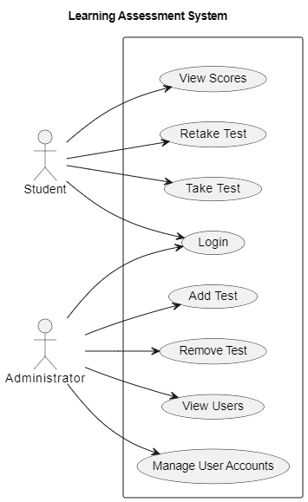

**Figure 3.1:** Use Case Diagram

**3.4.2 Data Flow Diagram**

Data Flow Diagram (DFD) is a visual representation of the information flow through a process or system. DFDs help you better understand process or system operations to discover potential problems, improve efficiency, and develop better processes. Creating a Data Flow Diagram (DFD) involves illustrating the flow of data within your Learning Assessment System.

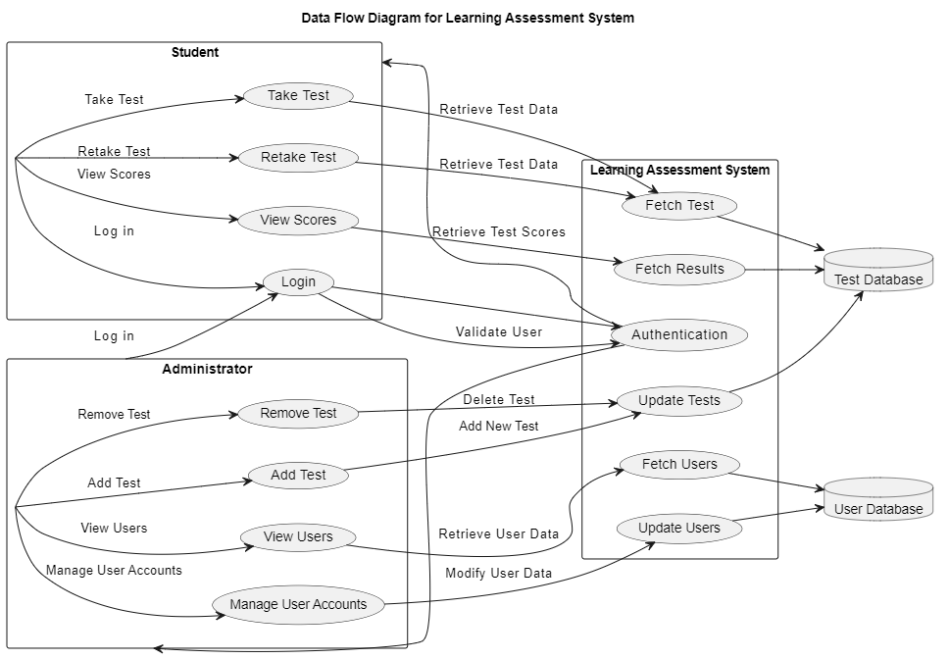

**Figure 3.2:** Data Flow Diagram

**Data Flow:**

* Student and Administrator are represented as separate rectangles containing their interactions with the system.
* Learning Assessment System contains the processes within the system.
* Test Database and User Database are represented as databases where the system stores and retrieves data.
* Arrows indicate the direction of data flow between processes and data stores.

**3.4.3 Entity Relationship Diagram**

An entity relationship diagram (ERD) is a graphical representation of database tables and their relationships to each other, usually used in software development projects regarding the organization of data within the databases or information systems. In the context of an Learning Assessment System., an ERD helps illustrate the relationships between key entities such as Students, and Administrators.

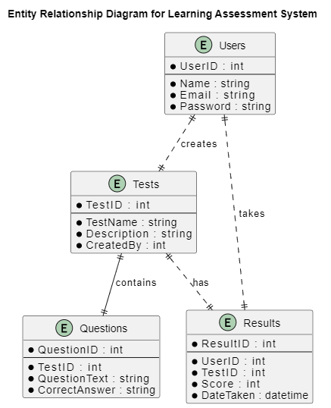

**Figure 3.3:** Entity Relationship Diagram

**ERD Explanation:**

* **Users:** This entity represents the users of the system. Each user has a unique ID, name, email, and password.
* **Tests:** This entity represents the tests in the system. Each test has a unique ID, name, description, and the ID of the user who created it.
* **Questions:** This entity represents the questions associated with each test. Each question has a unique ID, the ID of the test it belongs to, the question text, and the correct answer.
* **Results:** This entity represents the results of tests taken by users. Each result has a unique ID, the ID of the user who took the test, the ID of the test, the score, and the date the test was taken.

**Relationships:**

* A User can take multiple Results.
* A Test can contain multiple Questions.
* A User can create multiple Tests.
* A Test can have multiple Results.

**3.5 Chapter Summary**

This Chapter focuses on the analysis and design of the Learning Assessment System. It begins by outlining the adoption of the Agile software development model for its iterative and flexible approach, ensuring adaptability to evolving requirements and close alignment with user expectations through continuous feedback. The chapter then dives into requirement engineering, emphasizing activities such as elicitation, analysis, specification, validation, and management to capture and define stakeholder needs effectively.

The requirement specification section outlines functional requirements (user management, test management, user interactions, feedback mechanisms) and non-functional requirements (performance, scalability, reliability, availability, recoverability). System design methodologies, including Use Case diagrams, Data Flow Diagrams (DFD), and Entity Relationship Diagrams (ERD), are employed to visualize system architecture, data flow, and database relationships.

Overall, Chapter Three provides a structured framework for developing an efficient and user-friendly online testing platform, ensuring that the Learning Assessment System meets its objectives through thorough analysis.

**CHAPTER FOUR**

**SYSTEM IMPLEMENTATION**

**4.0 Introduction**

This chapter provides a detailed overview of the implementation process of the Learning Assessment System. It covers the technical tools and technologies utilized in the development, the testing methodologies employed to ensure system functionality, the system requirements necessary for deployment, and the evaluation methods used to gather feedback from stakeholders. This chapter aims to provide a comprehensive understanding of the implementation phase, highlighting the key components that contributed to the successful development and deployment of the Learning Assessment System.

**4.1 Technical Tools Used**

In The developing of the Learning Assessment System a variety of tools or technologies were used to ensure a flexible functionality, a friendly user interface scalability, and ease of use this tools was selected to meet my systems requirement and enhance the development process. Below is an outline of the main technologies used and their roles:

1. **Programming Language: PHP**

PHP is a widely-used open-source scripting language that is especially suited for web development. It is embedded within HTML and can be executed on the server side to create dynamic web pages.

**Features:**

* **Server-Side Scripting:** Handles client requests, manages sessions, and interacts with the database efficiently.
* **Cross-Platform Compatibility:** Runs on various operating systems, including Windows, Linux, and macOS.

1. **Database: MySQL**

MySQL is a relational database management system (RDBMS) that stores all necessary data, including user information, questions, options, results, and feedback.

**Features:**

* **Scalability:** Handles large volumes of data and concurrent users efficiently.
* **Complex Queries:** Supports complex queries, indexing, and joins for efficient data retrieval and manipulation.

1. **Web Server: Apache**

Apache HTTP Server is an open source and a flexible web server that hosts the application and serves web pages on the internet to users.

**Features:**

* **Security:** Provides robust security features, including authentication, access control, and SSL/TLS support.
* **Customizability:** Offers extensive modules and configuration options for customizing server behavior.
* **Performance:** Efficiently handles multiple client requests and delivers content quickly.

1. **Front-end Technologies: HTML, CSS, JavaScript**

These technologies form the backbone of the user interface, ensuring that web pages are structured, styled, and interactive.

**Features:**

* **HTML:** Structures content and elements on web pages.
* **CSS:** Styles web pages to create visually appealing layouts and designs.
* **JavaScript:** Enables dynamic content updates, interactive elements, and client-side validation.

1. **Integrated Development Environment (IDE): Visual Studio Code**

Visual Studio Code is a powerful IDE that provides a comprehensive environment for coding, debugging, and testing the application.

**Features:**

* **Syntax Highlighting:** Improves code readability and reduces errors through color-coded syntax.
* **Extensions:** Offers a wide range of extensions and plugins for enhancing development productivity.
* **Integrated Terminal:** Provides a built-in terminal for executing commands and running scripts directly from the IDE.
* **Debugging Tools:** Includes debugging capabilities for identifying and fixing issues in the code.

**4.2 System Testing**

System testing tests the integration of each module in the system. It also tests to find discrepancies between the system and it’s original objective, and current specification. The following table outlines the test cases used to verify the functionality of the Learning Assessment System:

|  |  |  |  |  |  |
| --- | --- | --- | --- | --- | --- |
| ID | FUNCTION | DESCRIPTION | EXPECTED RESULT | ACTUAL RESULT | STATUS |
|  | Sign up | User create new account | New user added to the system | User was added to the system | Successful |
|  | User login | User tries to log in with valid credentials | User is successfully logged in | User was successfully logged in | Successful |
|  | User login | User tries to log in with invalid credentials | Error message displayed | Error message was displayed | Successful |
|  | Take test | User attempts to start a test | Test is successfully initiated | Test was successfully initiated | Successful |
|  | View ranking | User attempts to view their rank | Scores and ranks are displayed | Scores were displayed | Successful |
|  | View history | User attempts to view history | History is displyed | History was displayed | Successful |
|  | Send feedback | User tries to send feedback | Feedback form is displayed | Feedback was sent to admin | Successful |
|  | Admin login | Admin tries to login with valid credentials | Admin successfully logs in | Admin was successfully logged in | Successful |
|  | Admin login | Admin tries to login with invalid credentials | Error message displayed | Error message was displayed | Successful |
|  | Add test | Admin adds a new test to the system | New test is added | New test was added to the system | Successful |
|  | Delete test | Admin deletes a test in the system | Test is removed | Test was deleted form the system | Successful |
|  | View Feedback | Admin attempts to view user feedback | User feedback is displayed | User feedback was displayed | Successful |
|  | View users | Admin attempts to view user | List of users is displayed | All users was displayed | Successful |
|  | Delete user | Admin tries to delete a user | User is removed | User was removed from the system | Successful |
|  | Admin sign out | Admin attempts to sign out | Admin signed out | Admin was signed out | Successful |

**Table 4.2:** Report for System Testing

**4.3 System Requirements**

The system requirements needed For optimal performance and usage of the Learning Assessment System, both software and hardware requirements are needed. These requirements ensure that the system operates efficiently, providing users with a seamless experience. Below are the detailed software and hardware requirements:

**4.3.1 Software Requirements**

* **Operating System:** Windows 10 or later, macOS, or Linux
* **Web Browser:** Google Chrome, Mozilla Firefox, Microsoft Edge, or Safari
* **Web Server:** Apache 2.4 or higher
* **PHP:** Version 7.4 or higher
* **Database:** MySQL 5.7 or higher

**4.3.2 Hardware Requirements**

* **Processor:** Dual-core processor or higher
* **RAM:** Minimum 4 GB
* **Storage:** Minimum 5 GB of available disk space
* **Network:** Reliable internet connection

**4.4 System Evaluation**

The evaluation of the Learning Assessment System was conducted to determine its effectiveness, usability, and overall satisfaction among its users. The evaluation aimed to gather valuable insights that could guide future improvements and ensure the system meets the needs of its users. This process involved structured feedback collection through surveys and interviews with students, instructors, and administrators.

1. **Students**

* **Ease of Navigation:** Students generally found the system intuitive and easy to use, allowing them to focus on assessments without technical distractions.
* **Instant Feedback:** The immediate results and feedback on assessments were highly appreciated, as they helped students understand their performance and areas needing improvement.

1. **Instructors**

* **Test Management:** Instructors valued the streamlined process for creating and managing tests, which saved them time and effort.
* **Performance Monitoring:** The ability to track and monitor student performance was seen as a significant advantage for providing targeted support.

1. **Administrators**

* **System Reliability:** Administrators found the system robust and reliable, with minimal downtime and issues, facilitating smooth operations.
* **User Management:** The system's user management capabilities were praised for their efficiency in handling user accounts and permissions.

**4.4.1 Overall Evaluation**

The feedback received from all users was overwhelmingly positive, indicating that the Learning Assessment System effectively meets user needs and expectations. Key strengths include ease of use, robust functionality, and efficient user management. However, the evaluation also highlighted several areas for future enhancements:

* **User Interface Design:** Improving the visual appeal and responsiveness of the interface to enhance user engagement and accessibility.
* **Advanced Features:** Implementing more sophisticated analytics and reporting tools to provide deeper insights into performance metrics.
* **Security Enhancements:** Strengthening security protocols to safeguard user data and ensure compliance with data protection standards.

The evaluation process provided valuable insights into the strengths and weaknesses of the Learning Assessment System. The feedback gathered will guide future development efforts, ensuring the system continues to evolve and meet the dynamic needs of its users. By addressing the identified areas for improvement, the System can enhance user satisfaction and maintain its position as a reliable and effective tool for learning assessment.

**4.5 Chapter Summary**

In this chapter, I talked about the implementation details of the Learning Assessment System, highlighting the technical tools and methodologies utilized to ensure a robust and effective application. We explored the various technologies employed, including PHP, MySQL, Apache, and front-end technologies, which together provided the necessary infrastructure for building a scalable and user-friendly platform.

The system testing section detailed the comprehensive testing approach undertaken to validate the functionality of each component, ensuring that the system operates seamlessly and fulfills its intended purpose. Test results demonstrated successful performance across all key functions, affirming the system's readiness for deployment.

System requirements were outlined to provide clarity on the necessary software and hardware configurations needed for optimal performance, ensuring users have a smooth experience when interacting with the system.

Finally, the system evaluation was conducted through feedback collection from students, instructors, and administrators, offering insights into the system’s effectiveness and areas for improvement. Positive feedback underscored the system’s ease of use, reliability, and robust functionality, while recommendations for enhancements focused on user interface improvements, advanced analytic, and strengthened security measures. The insights gained from testing and evaluation will guide future enhancements, ensuring that the system continues to meet the evolving needs of its users.